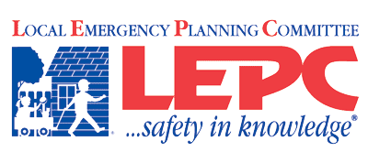
Lincoln County Kansas
__________________________________________________
Agenda
Date and Time: Monday, July 31, 2017 NOON
Lincoln County Emergency Services Building

- Roll call by sign-in
- Introduce guests
- Approval of last meeting’s minutes
- Communications/Mail
- Agency/individual reports

- Old Business
October 28 – Zombie Preparedness Night
Emphasis on Fire Safety, Pillowcase project
- New Business
LEPC Conference Report
Emergency Preparedness Law Conference Report
- Public Forum
- Adjourn

Appointed Members:
David Dohe– Emergency Management- Chair
Shawn Esterl, Environmental - Vice-Chair Steve Granzow, PIO/Media
Jeff White, Firefighting - Bret Kingan, Emergency Medical
Ladonna Reinert, Health – Secretary Jennifer O’Hare, Legal Counsel
Jon Ahlquist, Business and Industry Mike Weigel - Law Enforcement
Al Joe Wallace, Elected Official Scot Kerns, Community Groups
Kati Gardner, Hospital Michel O’Hare – Transportation

Invited Guests:
Randy Rathbun Kathy Robertson Jude Stecklein Richard Ubben (Tallgrass Energy)
Marc Lovin Ronald Nelson Brad Nitsch Dustin Florence
Travis Schwerdtfager Stuart Johnson(Southern Star)
Mark McMillin and Frank Georgiana (Enel EGP North America)
Deb Tucker (Red Cross) Sherry Angell

